**Installing 64-bit Oracle Data Access Components (ODAC) for BizTalk 2010**

I didn't find any good reference on this so though of documenting the steps that worked for me   
  
Step 1: Go to [64-bit Oracle Data Access Components (ODAC) Downloads page](http://www.oracle.com/technetwork/database/windows/downloads/index-090165.html) and download ***64-bit ODAC 11.2 Release 5 (11.2.0.3.20) Xcopy for Windows x64***

**[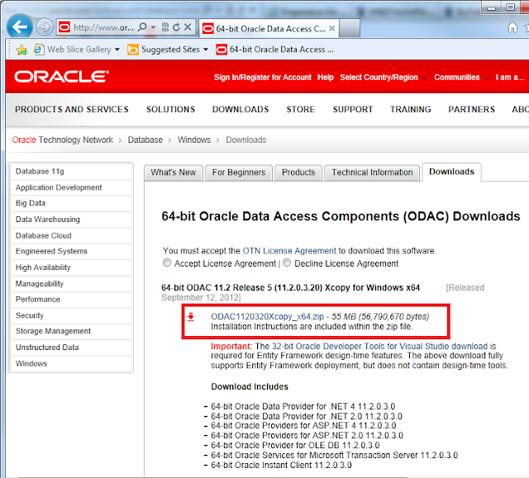](http://4.bp.blogspot.com/-y5FAZBIP5V4/UXBR4dglZrI/AAAAAAAAAcI/6Yfvdq_IIqo/s1600/001.png)**

Step 2: Unzip the file downloaded in Step 1 it to a folder location.

**[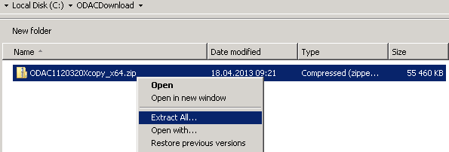](http://1.bp.blogspot.com/-sA5umVMtX80/UXBSSsw8k3I/AAAAAAAAAcQ/I6HyCKtVGWI/s1600/002.png)**

Step 3: Create a folder to install Oracle Client. I created ***C:\Oracle\ODAC_11_2_Release_5_64_Bit***    
  
Step 4: Run the command prompt as Administrator and browse to location where the zip file was extracted in Step 2.    
  
Step 5: Install Oracle Instant Client and Oracle Data Provider for .NET 2 by executing the following command on Command prompt:    
  
install.bat odp.net2 C:\oracle\ODAC_11_2_Release_5_64_Bit OraClient11g_home1 true

**[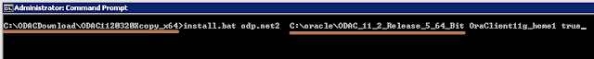](http://3.bp.blogspot.com/-ZyGQbSGBVDA/UXBSuQ3X6tI/AAAAAAAAAcY/tu4FQjXJTUg/s1600/005.png)**

Step 6: Install Oracle Data Provider for .NET 4 by executing the following command on Command prompt:   
  
install.bat odp.net4 C:\oracle\ODAC_11_2_Release_5_64_Bit OraClient11g_home1 false  
 **Note**: Use the same name OraClient11g_home1 for Oracle home in all commands.

[http://2.bp.blogspot.com/-le80ZCJ5Yuk/UX9rMBuFF2I/AAAAAAAAAdY/AAUN_Vu1YLQ/s640/006.png](http://2.bp.blogspot.com/-le80ZCJ5Yuk/UX9rMBuFF2I/AAAAAAAAAdY/AAUN_Vu1YLQ/s1600/006.png)

Step 7: Install Oracle Service for MTS by executing the following command on Command prompt:   
  
install.bat oramts C:\oracle\ODAC_11_2_Release_5_64_Bit OraClient11g_home1 false

**[http://1.bp.blogspot.com/-asFZpTK5c-I/UXBThbJCLvI/AAAAAAAAAco/n7XXlrjy7WQ/s640/007.png](http://1.bp.blogspot.com/-asFZpTK5c-I/UXBThbJCLvI/AAAAAAAAAco/n7XXlrjy7WQ/s1600/007.png)**

Step 8: Add the install directory (C:\oracle\ODAC_11_2_Release_5_64_Bit) and install directory's bin subdirectory (C:\oracle\ODAC_11_2_Release_5_64_Bit\bin) to the system environment variable **PATH**.   
  
Step 9: Create the system environment variable **ORACLE_HOME** and set it’s value to **C:\oracle\ODAC_11_2_Release_5_64_Bit**   
  
Step 10: Copy over/Create the tnsnames.ora to/at default location %ORACLE_HOME%/network/admin

**[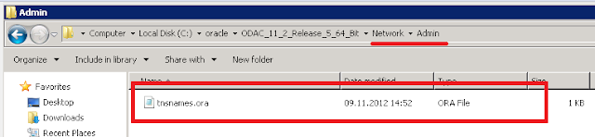](http://3.bp.blogspot.com/-ij5QRcPqpTc/UXBUN-ikF3I/AAAAAAAAAcw/13PU2ZPbRrE/s1600/009.png)**

Step 11: This step is optional if you need to change the language, territory or character set for the oracle client then in this case you need to change the value of registry key NLS_LANG available at path:   
  
HKEY_LOCAL_MACHINE\SOFTWARE\Oracle\KEY_OraClient11g_home1   
  
**Note:** If you have specified different name for oracle home instead of OraClient11g_home1 in above commands then you need to look for KEY_<OracleHome>   
  
That's all you are done with installation. In my case I was using only 64-bit host for WCF-Oracle but if you want 32-bit host then you need to install 32-bit oracle client by follow the above steps but do create different folder.